Movie Watchlist Manager
Software Construction and Development (SCD) Lab Project Report
Submitted By
Name: Ehaan Ahmad Durrani_L1F23BSSE0221
Course: Software Construction and Development (SCD) Lab
Project Title: Movie Watchlist Manager

1. Introduction
The Movie Watchlist Manager is a Java Swing desktop application developed to help users manage their personal movie collection. The system allows users to add movies, mark them as watched or unwatched, assign ratings, filter movies, and view statistical information about their watchlist.
The project was developed using Java, Swing GUI components, JUnit 5 for unit testing, and Git/GitHub for version control. It demonstrates the practical implementation of important software engineering concepts taught in the SCD course.

2. Objectives
The main objectives of this project are:
- To create a user-friendly desktop application using Java Swing.
- To implement event-driven programming using GUI controls.
- To apply exception handling for input validation and error management.
- To organize code using a layered architecture.
- To perform automated unit testing using JUnit 5.
- To use Git and GitHub for source code management.

3. Technologies Used
Technology | Purpose
Java | Core programming language
Java Swing | Graphical User Interface
Eclipse IDE | Development environment
JUnit 5 | Unit testing
Git | Version control
GitHub | Online repository hosting

4. Project Architecture
The application follows a three-layer architecture:
4.1 Model Layer
Package: movie.model
Contains the Movie class that stores movie information such as:
- Title
- Genre
- Year
- Watch Status
- Rating
4.2 Service Layer
Package: movie.service
Contains the WatchlistService class which handles:
- Adding movies
- Removing movies
- Rating movies
- Filtering movies
- Calculating statistics
4.3 User Interface Layer
Package: movie.ui
Contains the WatchlistUI class which provides the graphical interface for user interaction.
This separation improves maintainability and supports code refactoring principles.

5. Features of the Application
The Movie Watchlist Manager provides the following features:
Add Movies
Users can add movies by entering:
- Title
- Genre
- Release Year
Mark Movies as Watched/Unwatched
Users can update the watch status of any movie.
Rate Movies
Movies can be rated from 1 to 5 stars.
Delete Movies
Movies can be removed from the watchlist.
Filter Movies
Users can display:
- All Movies
- Watched Movies
- Unwatched Movies
Statistics Dashboard
The system displays:
- Total Movies
- Number of Watched Movies
- Average Rating
- Favorite Genre

6. Implementation of SCD Concepts
6.1 Event Handling
Event handling is implemented using ActionListeners attached to buttons.
Examples:
- Add Movie Button
- Mark Watched Button
- Mark Unwatched Button
- Rate Movie Button
- Delete Movie Button
- Filter Button
Whenever a button is clicked, the corresponding event handler method is executed.

6.2 Exception Handling
Exception handling ensures that invalid inputs do not crash the application.
Handled Exceptions:
Empty Title
The application prevents adding a movie without a title.
Invalid Year
The year must be between 1888 and 2100.
Duplicate Movie
A movie with the same title cannot be added twice.
Invalid Rating
Ratings must be between 1 and 5.
Movie Not Found
Operations on non-existing movies generate appropriate error messages.
Try-catch blocks are used throughout the application to display user-friendly error messages.

6.3 Code Refactoring
Code refactoring was applied to improve readability and maintainability.
Examples include:
- Separation into Model, Service, and UI packages.
- Creation of helper methods such as:
  - findByTitle()
  - makeButton()
  - refreshTable()
  - updateStats()
- Removal of duplicate code.
- Improved code organization.
These changes keep functionality unchanged while making the code easier to maintain.

6.4 Unit Testing
JUnit 5 was used for automated testing.
A total of 10 test cases were written to verify business logic.
Test Cases
- Add Movie with valid input
- Add duplicate movie
- Add movie with empty title
- Add movie with invalid year
- Mark movie as watched
- Rate movie with valid rating
- Rate movie with invalid rating
- Remove movie
- Filter movies by watch status
- Calculate average rating
All test cases passed successfully.

6.5 Git and GitHub
Git was used for version control during development.
GitHub was used to host the project repository online.
Benefits:
- Source code backup
- Version tracking
- Collaboration support
- Easy project sharing
Meaningful commit messages were used throughout development.
Examples:
- Initial commit: Add Movie Watchlist with GUI, service layer, and unit tests
- Add README with project description and setup instructions

7. User Interface Description
The graphical user interface consists of:
Add Movie Section
Allows entry of movie details.
Watchlist Table
Displays:
- Title
- Genre
- Year
- Watch Status
- Rating
Action Panel
Provides buttons for:
- Mark Watched
- Mark Unwatched
- Rate Movie
- Delete Movie
Statistics Section
Displays:
- Total Movies
- Watched Movies
- Average Rating
- Favorite Genre
Status Bar
Displays success and error messages.

8. Screenshots
Screenshot
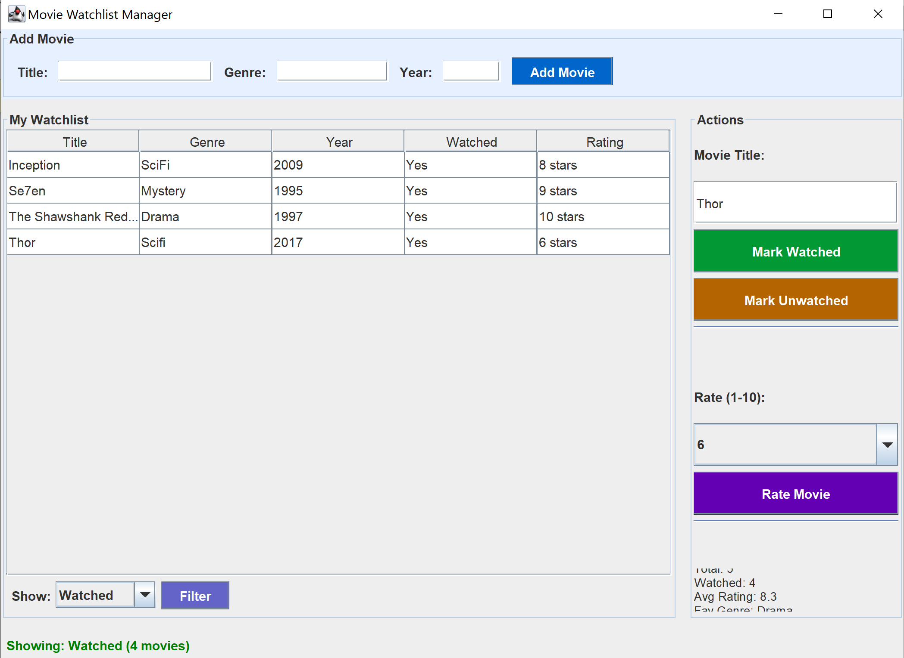

9. Results
The Movie Watchlist Manager was successfully developed and tested.
Achievements:
- Functional Java Swing GUI
- Proper event handling
- Effective exception handling
- Refactored and maintainable code
- Successful JUnit 5 testing
- GitHub integration
All project requirements specified in the SCD Lab were completed successfully.

10. Conclusion
The Movie Watchlist Manager successfully demonstrates the application of Software Construction and Development concepts in a real-world Java application. Through this project, concepts such as event handling, exception handling, code refactoring, unit testing, and version control were implemented and tested. The project provides a practical example of building a maintainable and reliable desktop application using Java Swing and modern software engineering practices.

